Pax Romana/Roman Achievements

The Pax Romana began during the reign of Rome’s first emperor, Augustus Caesar. The Pax Romana is considered a Golden Age of ancient Rome, and saw many advancements and achievements in science, technology, literature, and architecture.

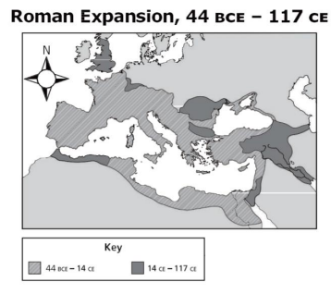
The Pax Romana is characterized by its strong economy. Taxes were used to pay for public works such as aqueducts and sanitation systems. Emperor Augustus focused heavily on the construction and maintenance of roads because they enabled the spread of peace and economic prosperity throughout the Roman Empire. Roads also increased and expanded Roman territory because they were easily traveled and defendable. Between 44BCE -117 CE, the Roman Empire conquered new territory and expanded its borders, as pictured in the map to the right.

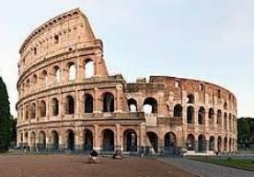
The Pax Romana also saw technological advancements with inventions such as aqueducts which helped to transfer fresh water throughout the Empire. Aqueducts, recognizable by their structural arches, enabled the growth of urban areas by increasing access to water in cities.

Pictured to the right is the famous Roman Colosseum. This structure was used to house, train, and fight gladiators, usually to the death, for entertainment of the emperor.

Roman Mythology

The ancient Romans were polytheistic and believed in many gods. The gods were very important in everyday life in Rome and were believed to display human-like characteristics. Roman mythology was based heavily on Greek mythology, so much so that Romans simply renamed/changed the Greek gods.

Jews in the Roman Empire

As the Roman Empire continued to expand, it conquered Judea (Israel), the remaining homeland of the Jewish people.

Concerned about the cultural influence of Rome and fearful that they were losing their religious identity, the Jews revolted against Roman rule.

The Romans reacted to the Jewish revolt with force, destroying the Temple of Solomon and leaving Jerusalem in ruins. The Romans conquered the Jews and expelled (forced out) them from their homeland, thus causing the Diaspora. The Jewish people migrated and scattered/spread around the world.

The Rise of Christianity

Christianity differs from the traditional Roman mythology because it is monotheistic, meaning Christians believed in just one god.

Christianity began with the teachings of a Jewish man named Jesus. Jesus’ disciples (followers) believed that he was the son of God, and the Messiah (savior of man). The growing power and influence of Jesus and his disciples threatened the Roman rulers, so they had Jesus crucified. Christians believe that Jesus was resurrected (raised from the dead), thus proving that he was divine (godly).

Jesus’ teachings continued to spread after his death largely because of his Apostles (closest twelve followers), like the Apostle Paul. The inclusion offered through Christianity and its simple message of forgiveness and salvation was appealing to many people, and contributed to the rapid spread of the new religion. Today, Christianity is the most practiced religion in the world.

The Fall of the Roman Empire and the Rise of the Byzantine Empire

Due to poor leadership, invasions from Germanic tribes, as well as disease and famine, the Roman Empire began to fall into disrepair. Food shortages and high taxes put merchants out of business. As the Roman economy continued to decline, people reverted back to a barter system, preferring to trade directly opposed to using Roman coins.

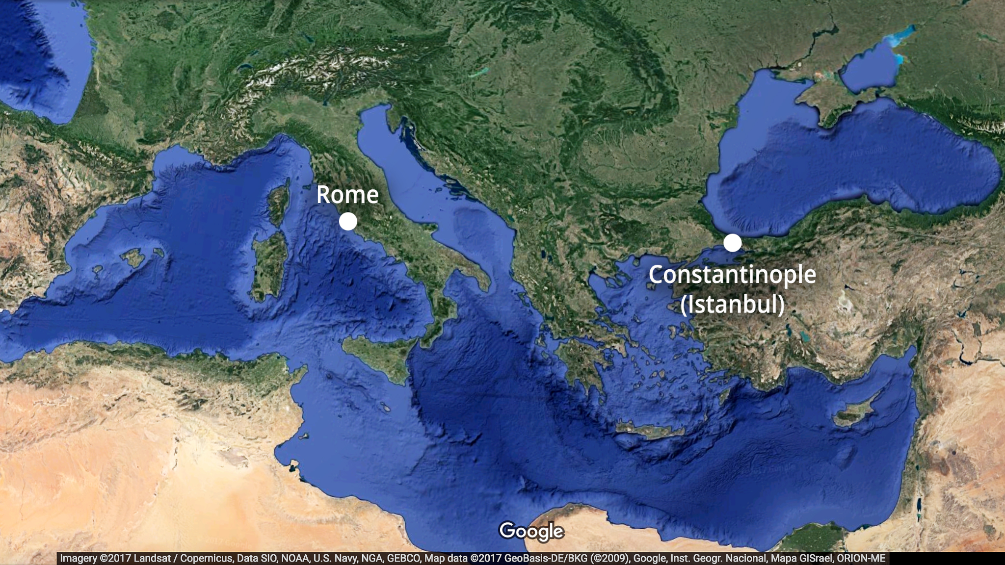
300 years after the birth of Jesus, Emperor Constantine the Great rose to power. Considered the first Christian emperor, Constantine enforced religious tolerance throughout the Roman Empire.

Constantine, recognizing the decline of the Western Roman Empire, moved the capital of the empire from Rome to Constantinople, nearer Asia Minor.

Constantinople, formally known as Byzantium, was geographically excellent because it was still centrally located in the Mediterranean region and could continue to serve a center for trade.

After a series of attacks, the Western Roman Empire was eventually fully conquered by northern tribes. The Eastern Empire, known as the Byzantine Empire was all that remained. The Byzantine Empire continued for another 1,000 years until it was conquered by the Ottoman Empire in the 15th Century.

Word Bank: Words will be used as many times as they appear.

Conquered
Augustus
Economy
Aqueducts
Sanitations Systems
Golden
Colosseum
Roads
Economic
Arches
Water
Expanded
Architecture

Changed
Human-like
Greek
Polytheistic

Scattering
Revolted
Temple
Jewish
Judea
Diaspora

Resurrected
Crucified
Messiah
One
God
Jesus
Monotheistic
Appealing
Spread
Paul
Christianity

Barter
Decline
Leadership
Business
Taxes
Chrsitian
Constantine
Byzantine
Rome
Trade
Decline
Constantinople
Mediterranean

