The Kingdom of Israel Divides
ESSENTIAL QUESTION What was the outcome of the conflict among the Israelites?
Faced by a threat of attack, Israelite tribes formed the kingdom of Israel. When the threat ended, the kingdom divided.

Israel and Judah King

Solomon died in 922 B.C. When Solomon’s son became king, the northern tribes refused to pledge their loyalty until he agreed to lighten their taxes and end their labor on building projects. When he refused, the tribes rebelled.
Only the tribes of Judah and

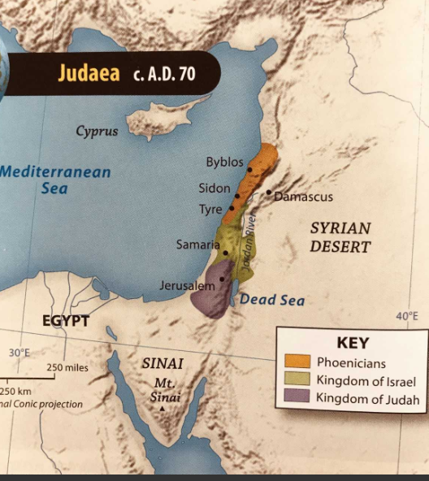

922 B.C.
A
I
C
I

Benjamin remained loyal.
Israel split into two separate kingdoms. The northern part continued to be called Israel.
The two tribes in the southern area, which included Jerusalem,
called their new nation Judah.

The words Judaism and Jews
come from the name Judah.

Two separate kingdoms existed for about two centuries. Throughout this period, Jerusalem remained an important center of worship.
S

Assyrians and Babylonians Take the Land By 738 B.C., both kingdoms faced new threats to their independence from the Assyrians. The Assyrians forced Israel and Judah to pay tribute. In 722 B.C., Assyria invaded Israel, whose army was weak, and conquered it. The kingdom of Israel ended. Around 612 B.C., the Assyrian Empire fell to the Chaldeans.
*The Chaldeans are also known as the Neo-Babylonians because they rebuilt the old Babylonian kingdom.
For many years, the Chaldean king Nebuchadnezzar ruled Babylon. In 586 B.C., Nebuchadnezzar captured Jerusalem. When Judah’s leaders resisted his rule, the Chaldeans destroyed the Temple in Jerusalem. They took thousands of Jews to Babylon as slaves.
